**Assignment Report**

* **Aim: -**

To create a *budget calculator* using User Interface Technologies.

* **Objective: -**

1. To successfully implement ‘Angular JavaScript’ in the project.
2. To create a calculator using HTML, CSS, Javascript in order to keep track of earnings and expenses during a certain time period.

* **Theory: -**

1. JavaScript:
   1. JavaScript is one of the core technologies of the World Wide Web. JavaScript enables interactive web pages and is an essential part of web application.
2. Angular js:
   1. **AngularJS**  is a  JavaScript-based  open source front-end web framework mainly maintained by Google to address many of the challenges encountered in developing single page applications.
   2. AngularJS's design goals include:
      1. to decouple DOM manipulation from application logic. The difficulty of this is dramatically affected by the way the code is structured.
      2. to decouple the client side of an application from the server-side. This allows development work to progress in parallel and allows for reuse of both sides.
      3. to provide structure for the journey of building an application: from designing the UI, through writing the business logic, to testing.

* **Technical Details: -**
  + The AngularJS framework works by first reading the HyperText Mark-up Language (HTML) page, which has an additional custom HTML attributes embedded into it.
  + Angular interprets those attributes as directives to bind input or output parts of the page to a model that is represented by standard JavaScript variables.
  + The values of those JavaScript variables can be manually set within the code, or retrieved from static or dynamic JSON resources.
* **Other Technologies Used : -**

1. HTML
2. CSS
3. JavaScript
4. JQuery
5. JSON
6. Boothstrap

* **Output: -**

**1.**

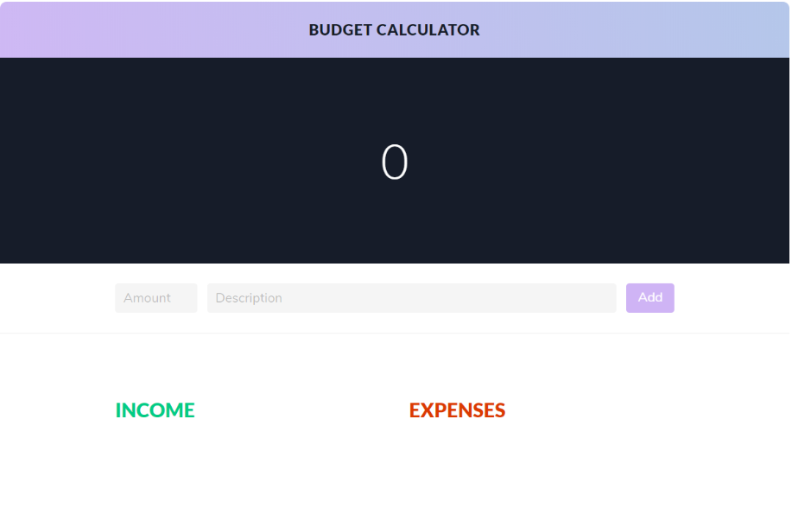

**2**.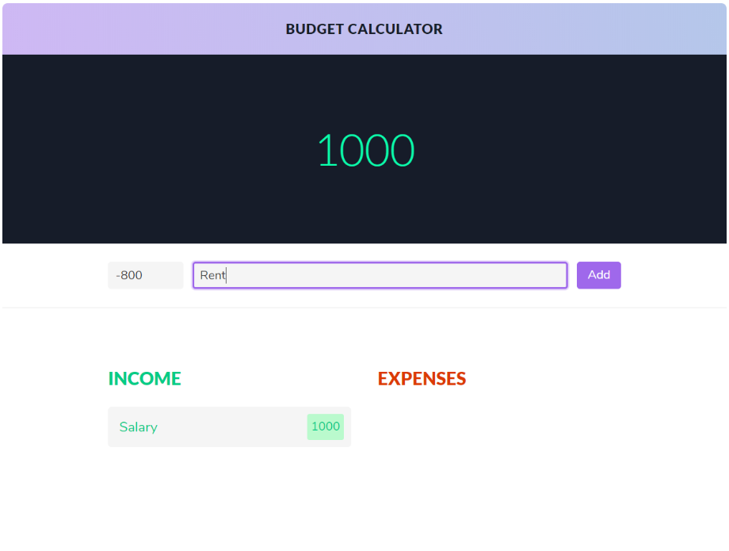

3.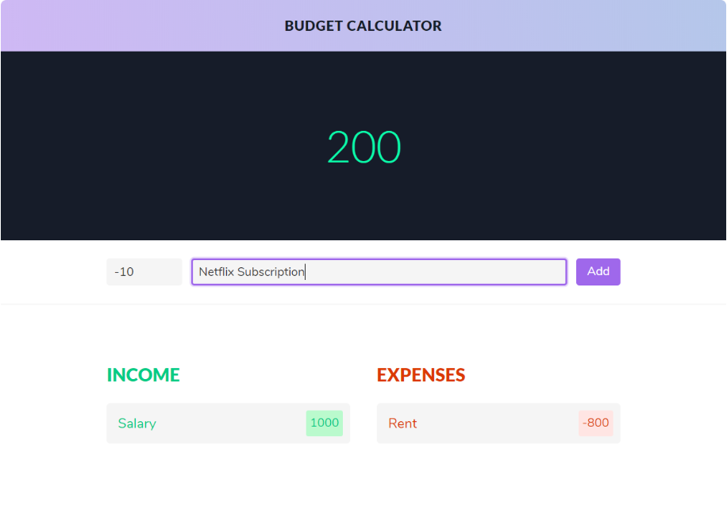

4.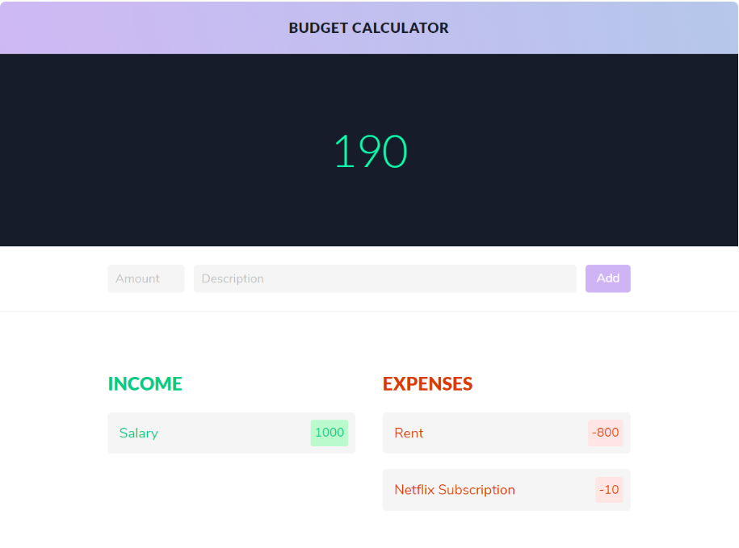

5.